CYCLES

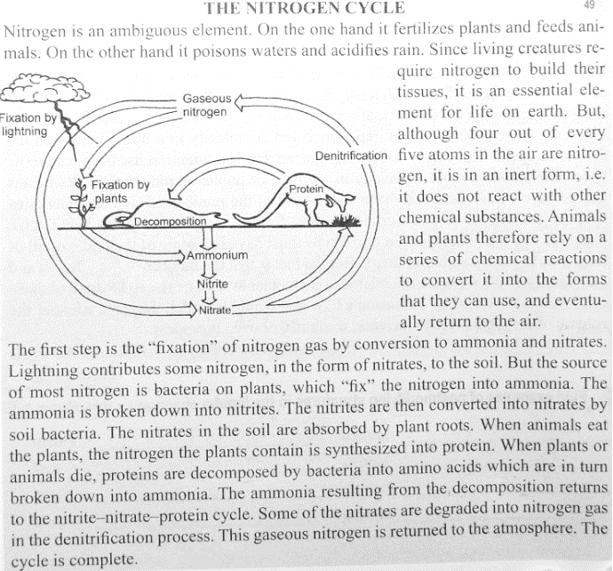
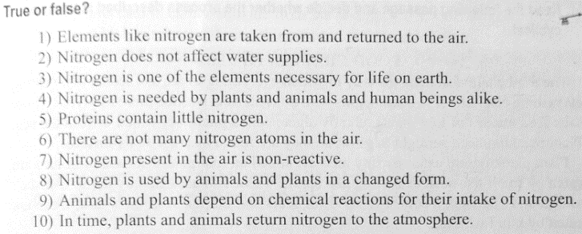

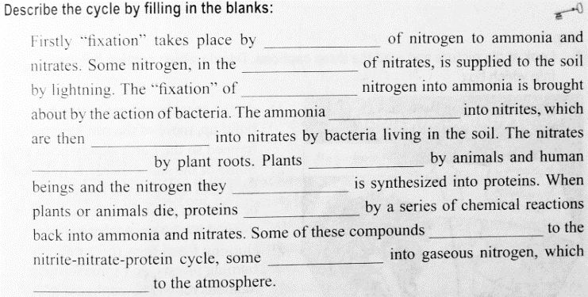
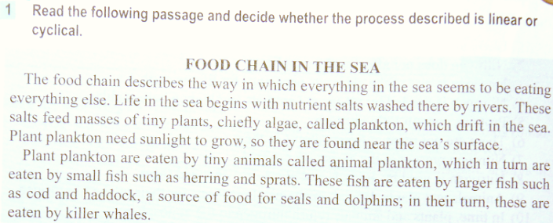

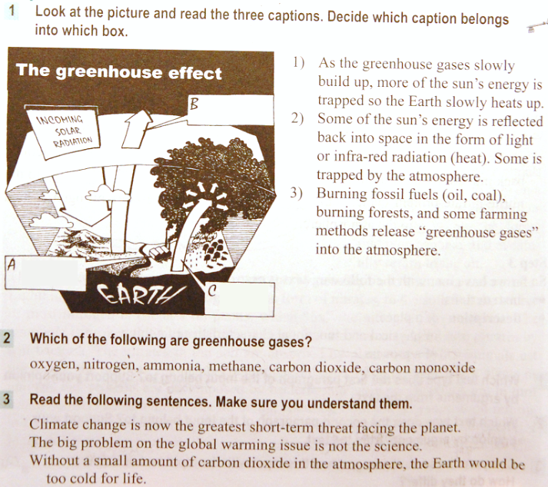

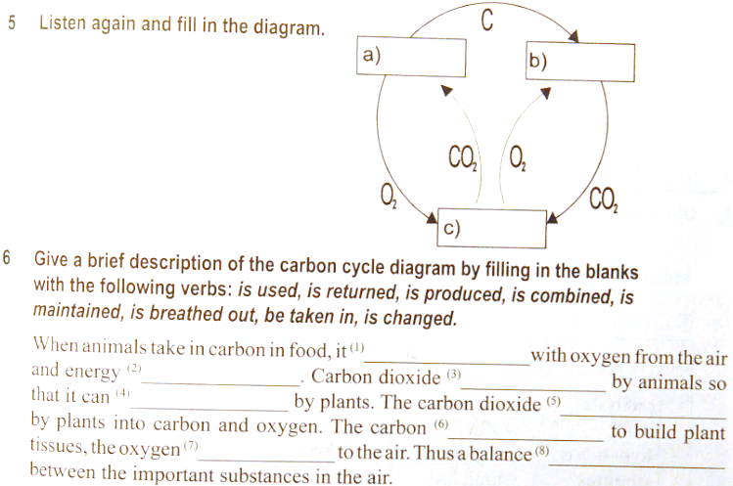
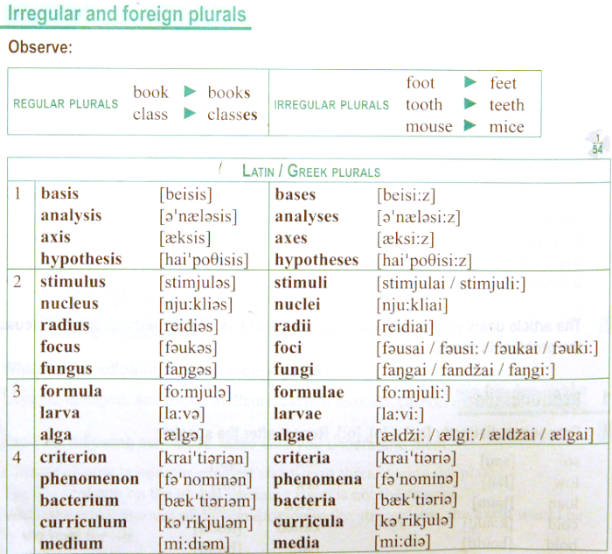

Ex. 1 Choose the correct word for each of the following and give the plural form:
(analysis, criterion, memorandum, phenomenon, formula, datum, crisis, medium)

a) ………………………….. are facts given.
b) ………………………….. are observed events.
c) ………………………….. are decisive moments.
d) ………………………….. are channels of communication.
e) ………………………….. are notes to assist the memory.
f) ………………………….. are standards or means of judging.
g) ………………………….. are general expressions for solving problems.
h) ………………………….. are separations of things into their parts or components.

Ex. 2 Fill in a suitable expression in the correct form:
(radius, formula, datum, criterion, focus, spectrum, crisis, vertex, nucleus, curriculum vitae. They may be used more than once)
a) The ………………………….. of a circle is the length of a straight line drawn between the centre and the outside edge.
b) We had to learn many chemical ………………………….. at school but I can only remember H₂O for water.
c) The ………………………….. was/were collected by various researchers.
d) The Health Service should not be judged by financial ………………………….. alone.
e) All the line segments extending from the centre of a circle are called …………………………..
f) In physics the point where waves of light or sound which are moving towards each other meet is called a …………………………..
g) A ………………………….. is a short group of letters, numbers or other symbols which represent a scientific or mathematical rule.
h) The set of colours into which a beam of light can be separated is called a …………………………..
i) Now the ………………………….. is being transferred from magnetic tape to hard disc.
j) The ………………………….. I apply to (= by which I decide about) any problem is “What will make me happiest?”
k) I´ve passed several ………………………….. during my illness, but the fever´s started to go down yesterday.
l) How many ………………………….. are there in a triangle?
m) Nuclear fission means the dividing of a ………………. and nuclear fusion means the joining of the two ………………
n) My uncle´s ………………………….. written before and after the Velvet revolution differ a lot.

